IPND Build Guide – AWS Addendum

# Account Password Policy

Set account password policy by running CloudFormation script 00-account-password-policy.yaml

# Route 53 Zones

Create the Route 53 Zones by running CloudFormation scripts 00-zone-private.yaml and 00-zone-public.yaml

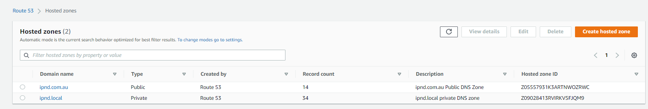

# VPC

Create VPCs using cloud formation scripts 01-vpc-2azs-prod.yaml and 01-vpc-2azs-nonprod.yaml

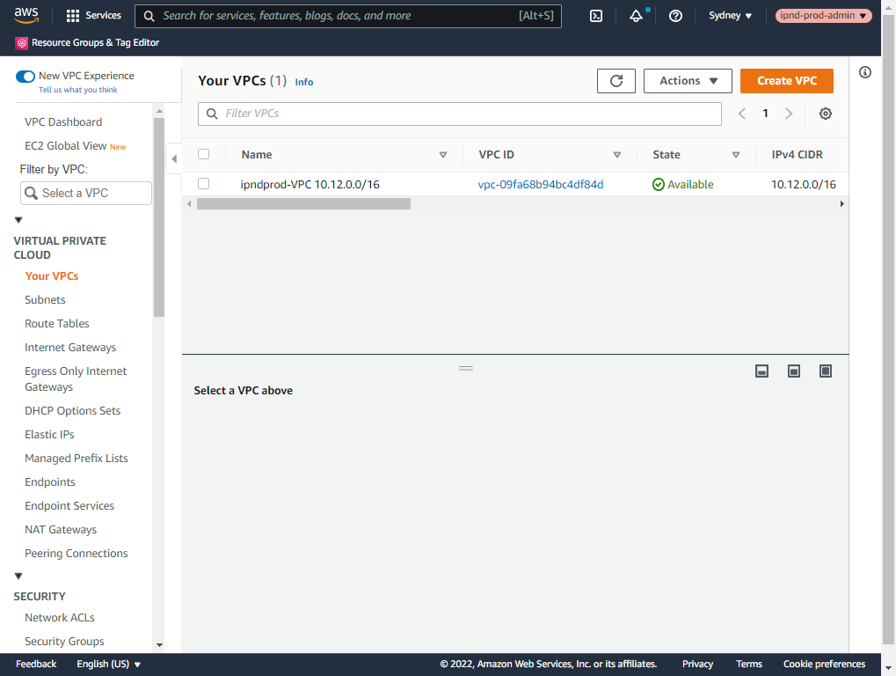

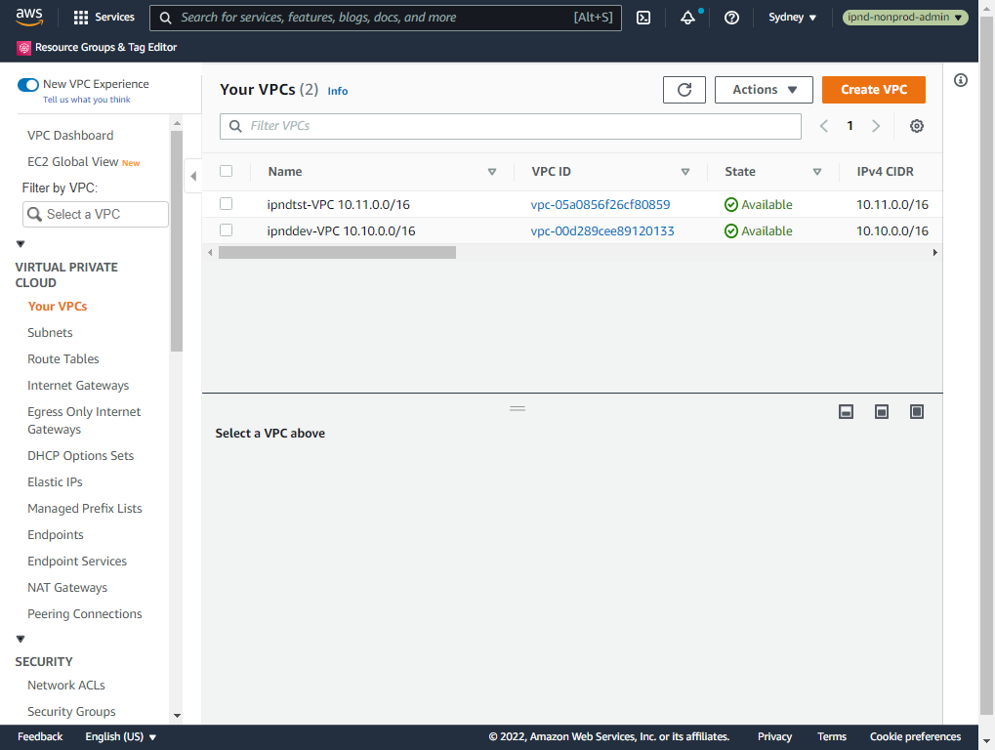

# Elastic IPs

Allocate static public IPs (elastic IPs) used for Bastion and VPN servers by running the CloudFormation script 02-elastic-ips.yaml

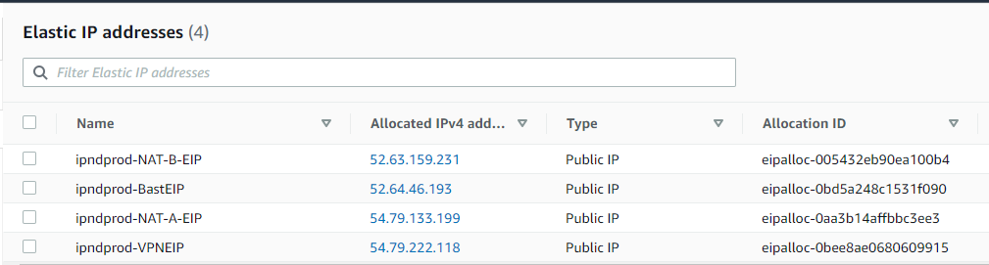

# KMS Keys

Setup separate encryption keys for EC2, EFS, S3, RDS, CodeCommit and Secrets Manager by running the CloudFormation script 02-kms-keys.yaml

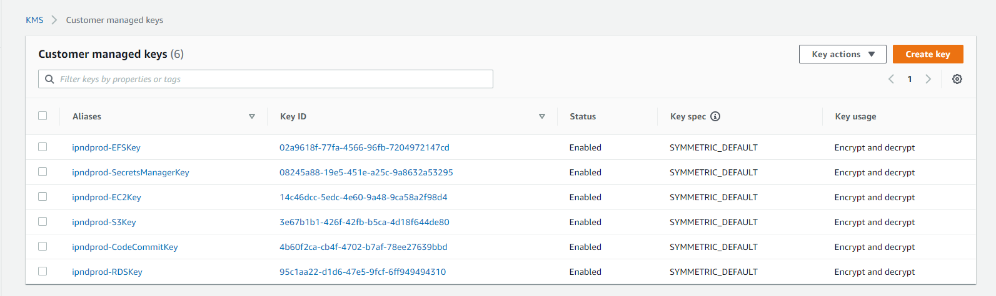

# Security Groups

Create Security Groups and the allowed traffic flows, protocols and ports by running the CloudFormation script 02-security-groups.yaml

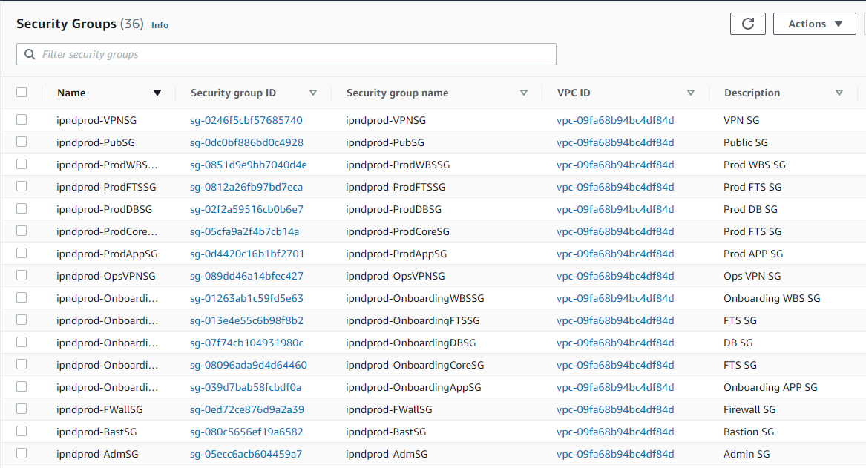

# Network Interfaces

Create Elastic Network Interfaces to be used for assigning static IP addresses to EC2 instances by running the CloudFormation script 03-network-interfaces.yaml

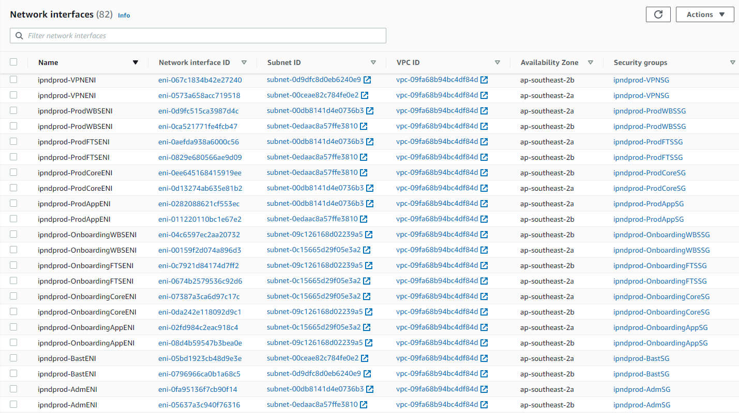

# NAT Gateways

Provision NAT gateways to enable one way access to internet from private subnets for reaching AWS services and update servers for pulling patches etc. by running CloudFormation script 04-nat-gateways.yaml

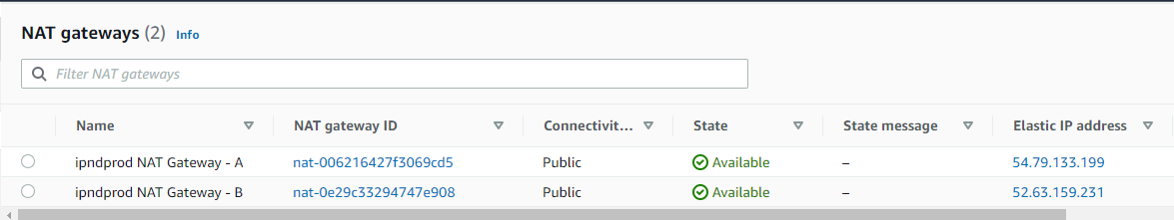

# VPC Endpoints

Provision VPC endpoints for S3 and SimpleEmailService so instances can reach these AWS services through internal network instead of traversing internet. CloudFormation script 04-vpc-endpoints.yaml.

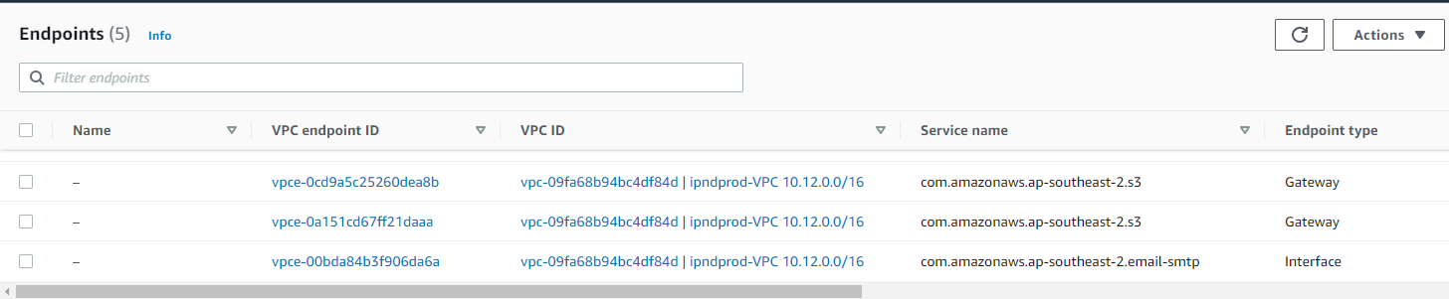

# EFS Filesystems

Allocate EFS storage to be used by EC2 instances by running the CloudFormation scripts:

05-elastic-file-system-set-common.yaml

05-elastic-file-system-set-onboarding.yaml

05-elastic-file-system-set-prod.yaml

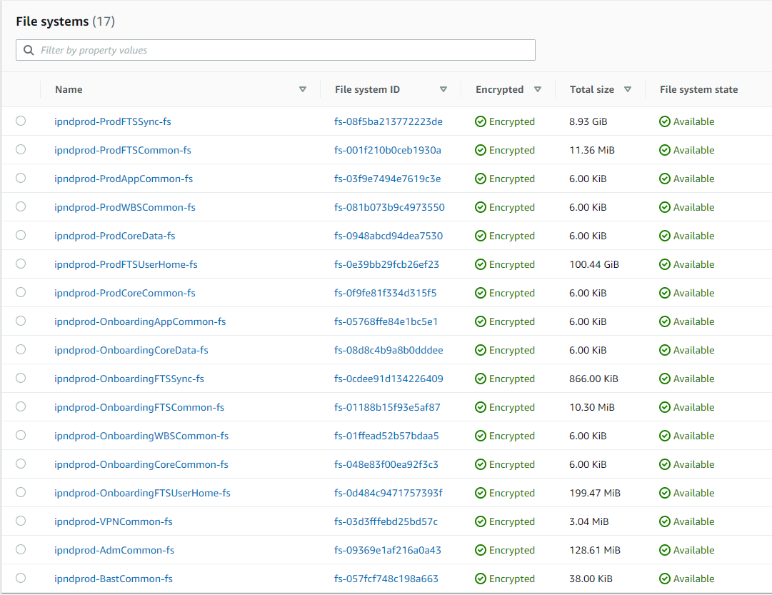

# MariaDB Credentials

Create MariaDB credentials in Secrets Manager using CloudFormation script 06-secretsmanager-mariadbsecret.yaml

# MariaDB Options

Create MariaDB options set using CloudFormation script 07-mariadb-options.yaml

# MariaDB RDS

Provision MariaDB instance by executing CloudFormation script 08-rds-mariadb.yaml

# EC2 Instances

## Launch templates

Create launch templates from the below json files from the AWS Code Commit infra code repository at <https://git-codecommit.ap-southeast-2.amazonaws.com/v1/repos/ipnd-infra> .

padmLaunchTemplate.json

pbastLaunchTemplate.json

pftsLaunchTemplate.json

pvpnLaunchTemplate.json

uftsLaunchTemplate.json

pcoreLaunchTemplate.json

ucoreLaunchTemplate.json

papsLaunchTemplate.json

uapsLaunchTemplate.json

pwbsLaunchTemplate.json

uwbsLaunchTemplate.json

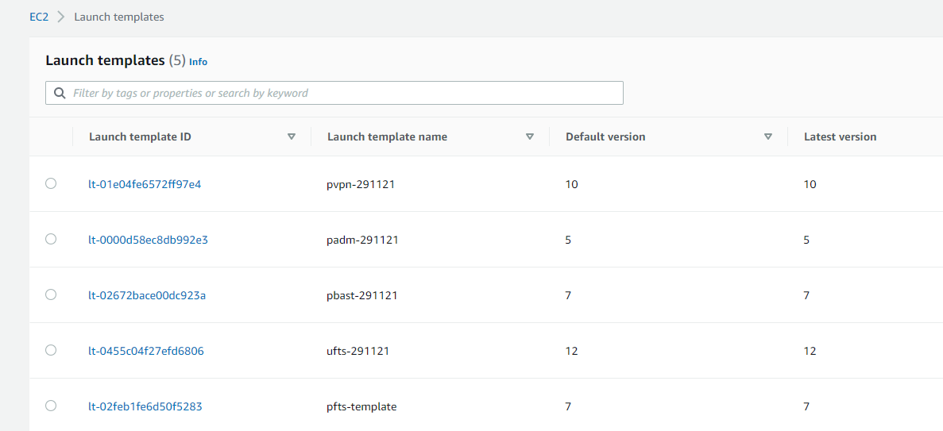

## Auto Scaling Group

Create Autoscaling group for each server from the above templates with minimum and maximum instance count to 1.

